Literary Excursions Presents
Hawa Allan and Sarina Prabasi
Monday, June 10, 2019 at 6:30-8 p.m.
Setauket Neighborhood House in East Setauket
95 Main Street, East Setauket, NY 11733
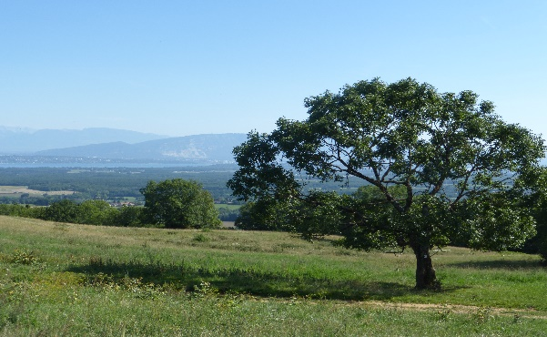
Hawa Allan writes cultural criticism, fiction, and poetry. Her work has appeared, among other places, in The Baffler, the Chicago Tribune, Lapham's Quarterly, and Tricycle magazine, where she is a contributing editor. Insurrection, her interweaving of legal history and personal narrative, is forthcoming from W.W. Norton.
Sarina Prabasi is author of The Coffeehouse Resistance: Brewing Hope in Desperate Times (Green Writers Press, April 2019), Co-Founder of Buunni Coffee and CEO of WaterAid America. Following a career leading initiatives in global health, education, water and sanitation, Sarina moved with her husband, Elias, from Addis Ababa to New York City, where they started Buunni Coffee together. Today, Buunni is a thriving business and a hub for community conversation and action.

For more information contact carmenbugan@gmail.com
About the conveners: Dr. Carmen Bugan is an award-winning memoirist, poet, and critic whose work has received international praise. Her books are: Lilies from America, Crossing the Carpathians, The House of Straw, Releasing the Porcelain Birds: Poems after Surveillance, Burying the Typewriter: Childhood Under the Eye of the Secret Police, and Seamus Heaney and East European Poetry in Translation: Poetics of Exile. Pramila Venkateswaran, poet laureate of Suffolk County 2013-15, is the author of Thirtha, Behind Dark Waters, and most recently, The Singer of Alleppey. She teaches at SUNY Nassau.

